Eddy Cadet Dr. Qin
Nov 5, 2007 Bio Informatics

Lab 9 Report
Building Trees using Non-coding DNA Sequences

1.3 Mitochondria DNAs from human, Neanderthal, and Chimpanzee.
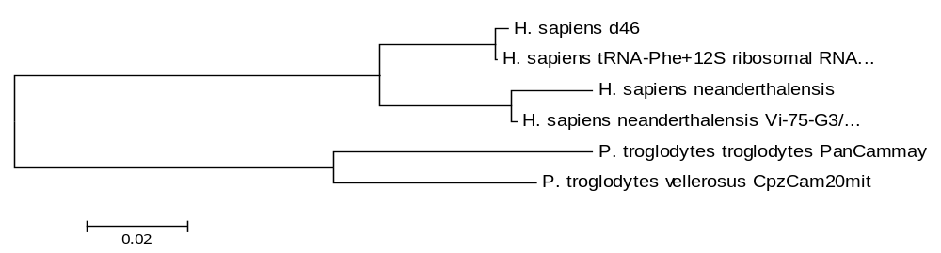

The above tree was generated using data from Genbank (NCBI). This tree is comparing mitochondria DNA of H . Sapiens d 46, h. sapiens neanderthalensis and P troglodytes. According to the tree, H. sapiens and H sapiens neanderthalenses are more closely related, whereas P troglodytes vellerosus are more distant. This analysis was conducted in MEGA 4

2.2 Nonsynonomous Tree
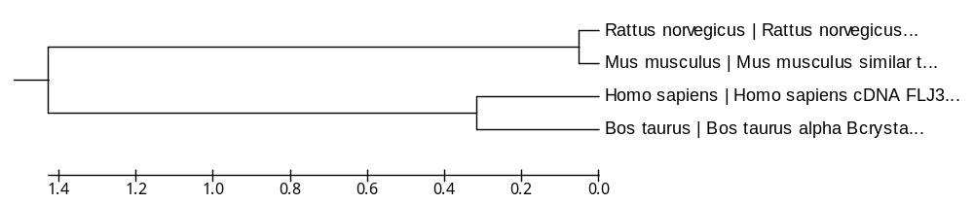

The above tree was generated using the UPGMA method. It is a nonsynonomous tree showing the relationship between Rattus nevegicus Mus musculus, Homo sapiens, Bos Taurus. Accroding to the tree, Rattus novegicus and Mus musculus are closely related, and so are homo sapiens and Bos taunus. However, Ratus novegicus/Mus musculus are distantly related to Homo sapiens and Bos taunus.

2.3 Synonymous tree for Rattus norvegicus, Mus musculus and Homo sapiens and Bos Taurus.

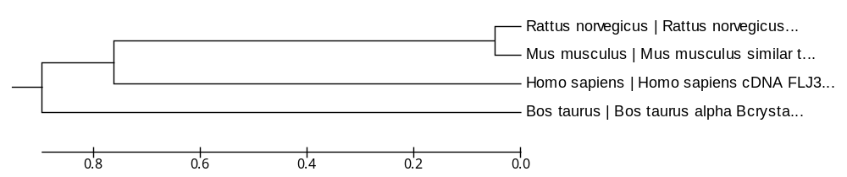

This tree uses the same data given in 2.2, except this it was constructed as using synonymous only- option in the program. Note the difference between the trees. The different structures are a reflection on the way the tree matrices are calculated. It shows how calculation of trees by distance is defferent when using the UPGMA or Non synonymous method (2.2) and the substitution model (2.3).

